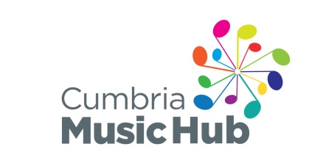
Workshop/Sharing Concert with National Youth Jazz Orchestra Ambassadors
Name
Date of birth |  |  |  |  | Male/Female
Address
Postcode |  |  |  |  | Tel. No.
Emergency Contact (must be available during sessions) | Contact Name: |  |  |  | Contact number:
Email (parent)
School
Instrument (principal) |  | Standard  Grade: |  | Instrumental music teacher:
Instrument (additional) |  | Standard  Grade: |  | Instrumental music teacher:
How confident are you at improvising with your instrument? | CONFIDENT SOME EXPERIENCE NEVER IMPROVISED
Please give details of any special needs, illnesses or allergies we should know about.
We plan to take photos or videos at this event for Cumbria Music Hub and NYJO promotional use. No players will be identified by name. If you DO NOT want images of your child used in this way please tick here

I would like my child to attend the NYJO workshop  Parent/Guardian signature: |  |  |  |  |  |  | Date:
Please return application form to Janet Brown, Cumbria Music Service, St Michael’s Centre, Station Road, Workington CA14 2UY or by email to Janet.Brown@cumbria.gov.uk by Tuesday 8th May 2018.

Personal information provided will only be used by Cumbria Music Service as the lead organisation for the Hub for this event and will not be passed to other individuals or organisations. We will share student name, instrument, level details and experience with NYJO workshop leader.

